ARTIFICIAL INTELLIGENCE | ASSIGNMENT 01
Exploratory Data Analysis
of the Heart UCI Dataset
Validated answers, reproducible Python code, and visual interpretation
303  PATIENTS | 13  INPUT FEATURES | 1  TARGET | 0  MISSING VALUES
Prepared by Abdullah Amer
Python | Pandas | Matplotlib | July 2026
ACCURACY REVIEW The responses were checked against the exact processed heart.csv file used in the assignment. Terminology and graph interpretations were tightened to avoid claims that the plots alone cannot establish.

Dataset Structure and Validation
Answers below refer to the processed heart.csv file loaded by the assignment code.

1. Identify the input feature variables and the target variable.
VERIFIED ANSWER
Input features (13): age, sex, cp, trestbps, chol, fbs, restecg, thalach, exang, oldpeak, slope, ca, and thal.
Target variable: target.

2. How many total patients and features are in this dataset?
VERIFIED ANSWER
There are 303 patients (rows), 13 input features, and 1 target variable. Therefore, the DataFrame contains 14 columns in total.
TERMINOLOGY NOTE If the form asks for features, answer 13. If it asks for total columns or variables including the target, answer 14.

3. What are the minimum and maximum values of the trestbps variable?
VERIFIED ANSWER
Minimum resting blood pressure: 94 mm Hg. Maximum resting blood pressure: 200 mm Hg.

4. Which variable is explicitly stored as a continuous floating-point data type?
VERIFIED ANSWER
oldpeak is stored as float64 in this CSV. The remaining columns are stored as int64.

5. Does the dataset contain any missing or null values?
VERIFIED ANSWER
No. The processed heart.csv file contains 0 missing values and 0 null values across all 303 rows and 14 columns.
SCOPE NOTE This result applies to the processed CSV used here. The broader original UCI collection contains multiple source files and should not be described using this result.

6. Plot a histogram showing the distribution of age.
import matplotlib.pyplot as plt

data["age"].hist(bins=6)
plt.xlabel("Age")
plt.ylabel("Number of patients")
plt.title("Age distribution")
plt.show()

# The largest bin is approximately 53-61 years.

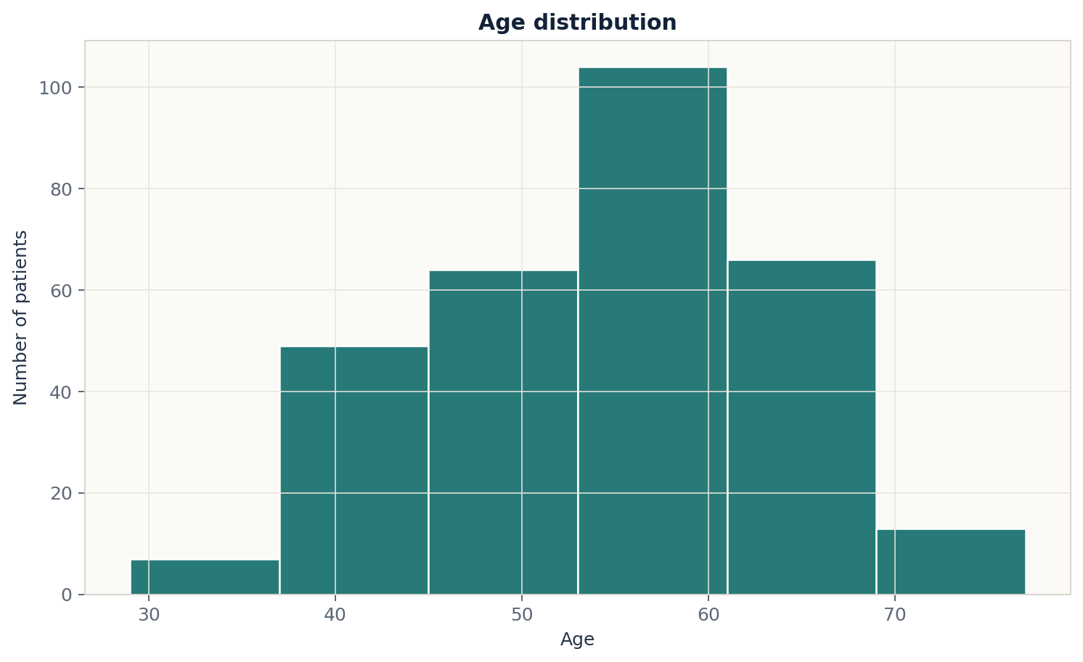
Figure 1. Distribution of patient age using six bins.
VERIFIED INTERPRETATION The sample is concentrated in middle and older adulthood. The largest six-bin interval is approximately 53-61 years. Only 16 patients are younger than 40, and only 6 are older than 70. This describes the composition of this dataset, not the frequency of heart-disease evaluation in the general population.
Evidence: 136 of 303 patients are between ages 50 and 60 inclusive; the exact six-bin peak contains 104 patients.

7. Draw a boxplot of thalach grouped by the target variable.
data.boxplot(column="thalach", by="target")
plt.xlabel("Target")
plt.ylabel("Maximum heart rate achieved (bpm)")
plt.title("Maximum Heart Rate (thalach) by Target")
plt.suptitle("") # Remove the default automatic title.
plt.show()

# Target 1 has a higher median thalach than Target 0.

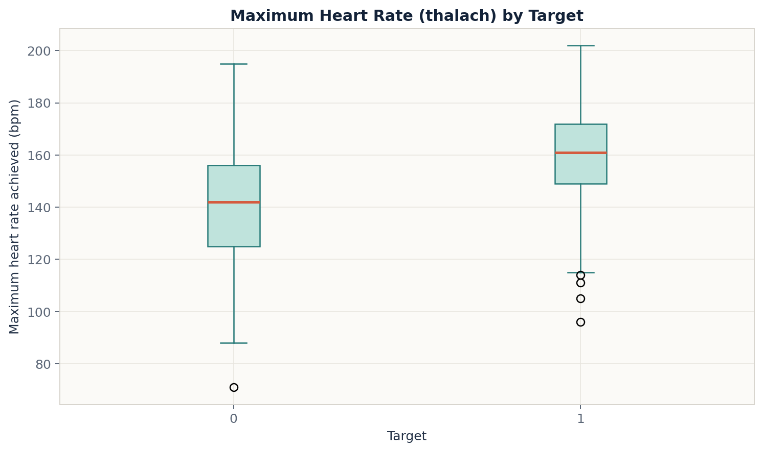
Figure 2. Maximum heart rate achieved, grouped by target.
VERIFIED INTERPRETATION Patients in the target = 1 group generally achieved higher maximum heart rates than those in target = 0. The distributions still overlap, so thalach does not perfectly separate the groups. A small number of low-value outliers are visible.
Evidence: Median thalach is 161 bpm for target 1 versus 142 bpm for target 0, a difference of 19 bpm.

8. Create a scatter plot of age vs. thalach, using target to color the points.
plt.scatter(
data["age"], data["thalach"],
c=data["target"], cmap="coolwarm", alpha=0.6
)
plt.xlabel("Age (years)")
plt.ylabel("Maximum heart rate achieved (bpm)")
plt.title("Age vs. Maximum Heart Rate, Colored by Target")
plt.show()

# thalach tends to decrease as age increases.

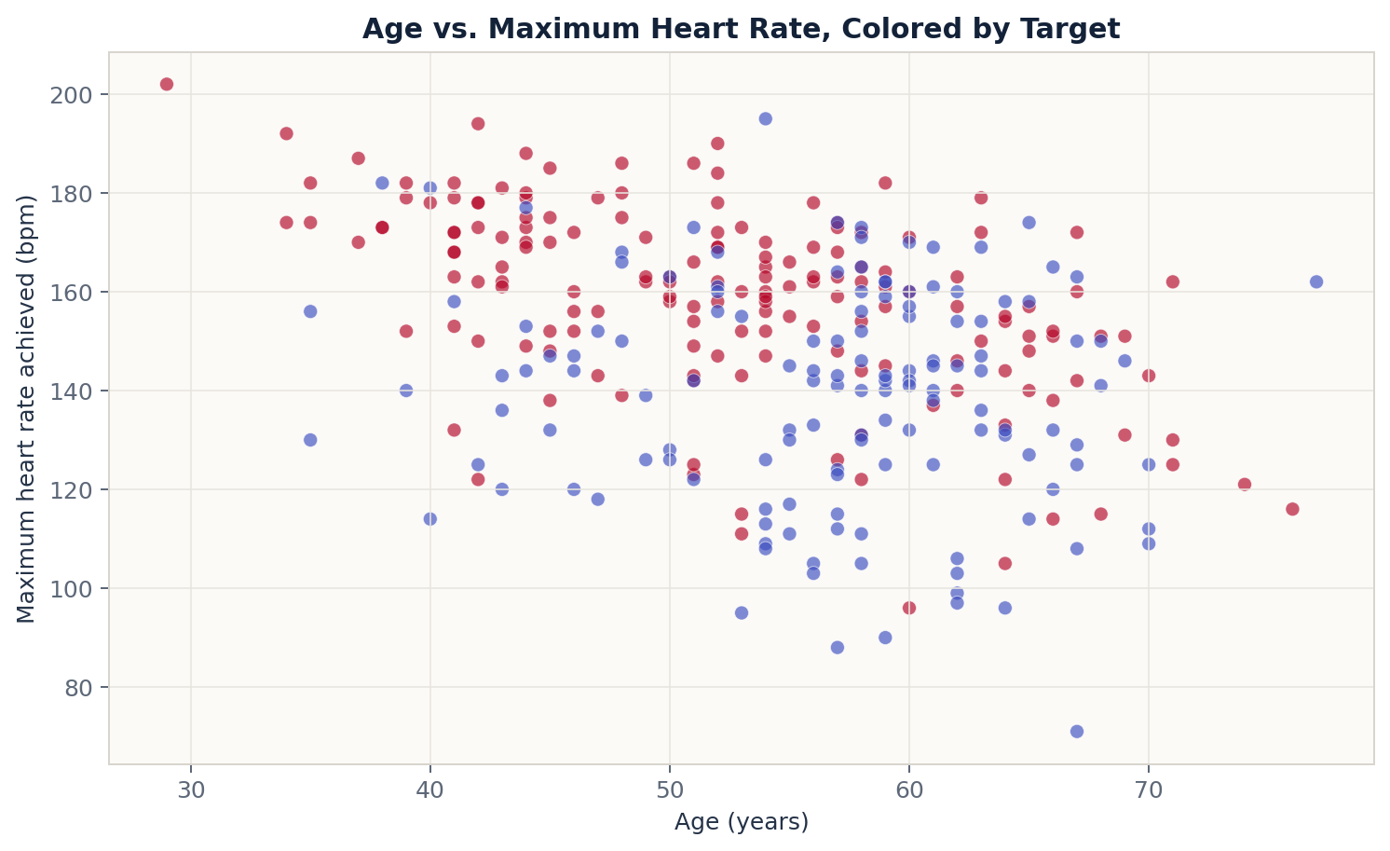
Figure 3. Age versus maximum heart rate, colored by target.
VERIFIED INTERPRETATION Maximum heart rate tends to decrease as age increases. The relationship is moderate rather than perfect, and the target groups overlap substantially. Color suggests some group separation, but age and thalach alone do not provide a complete classification rule.
Evidence: The Pearson correlation between age and thalach is approximately -0.40.

9. Draw a boxplot of chol grouped by the target variable.
data.boxplot(column="chol", by="target")
plt.xlabel("Target")
plt.ylabel("Cholesterol (mg/dL)")
plt.title("Cholesterol by Target")
plt.suptitle("") # Remove the default automatic title.
plt.show()

# The groups overlap strongly, with several high outliers.

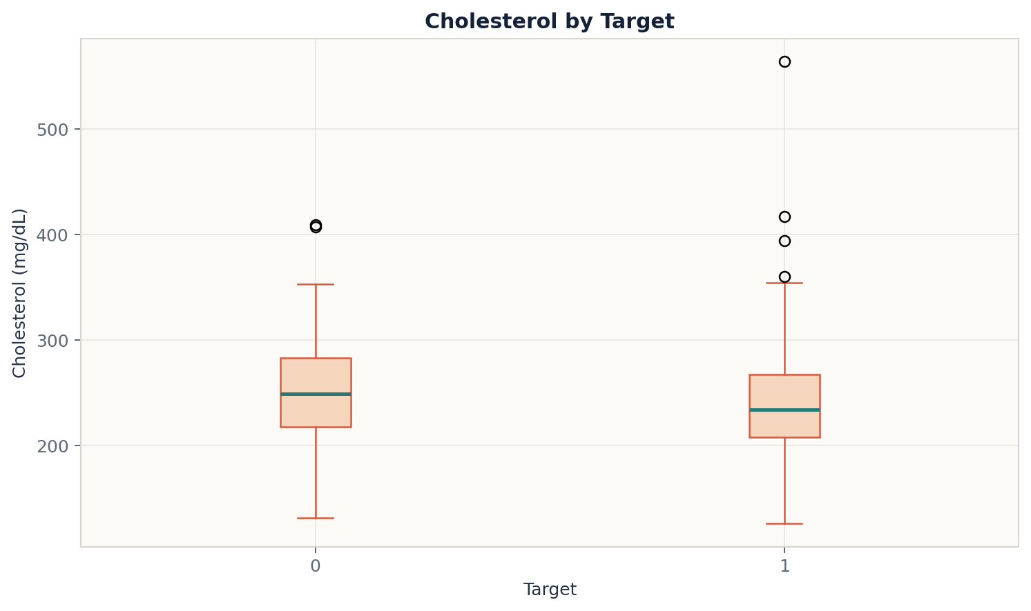
Figure 4. Cholesterol distribution grouped by target.
VERIFIED INTERPRETATION The cholesterol distributions overlap strongly. Target 0 has a slightly higher median, while both groups contain high-value outliers. The plot suggests limited standalone separation, but predictive usefulness cannot be concluded from a boxplot alone and would require formal modeling and validation.
Evidence: Median cholesterol is 249 mg/dL for target 0 and 234 mg/dL for target 1. The IQR rule identifies 2 high outliers in target 0 and 4 in target 1.

10. Provide brief comments and analytical insights for each graph.
The following statements are descriptive findings from this 303-patient sample. They do not establish causation or clinical diagnostic performance.
GRAPH | OBSERVED PATTERN | CAREFUL INTERPRETATION
Age histogram | Most observations are concentrated in middle and older adulthood, with the largest bin near ages 53-61. | This shows the sample's age composition; it does not prove that evaluations are more common in this age group generally.
Thalach boxplot | Target 1 has a higher median maximum heart rate (161 bpm) than target 0 (142 bpm). | The groups overlap, so thalach alone cannot perfectly separate target status.
Age vs. thalach | Maximum heart rate decreases as age increases; r is approximately -0.40. | This is a moderate negative association in the sample, not evidence that age directly causes the change.
Chol boxplot | The distributions are similar and overlapping; target 0 has a slightly higher median. | Cholesterol shows limited visual separation alone. Predictive value requires a validated model, not only a boxplot.

Final Accuracy Notes
CORRECTED WORDING Use '13 input features and 1 target (14 columns total)' rather than calling all 14 columns features.
The statement that cholesterol is a weak predictor was softened. A boxplot can show overlap, but model-based evaluation is needed to quantify predictive strength.
The age comment was also narrowed to this sample. Dataset concentration does not establish how often heart-disease evaluations occur in the wider population.

Sources
1. Janosi, A., Steinbrunn, W., Pfisterer, M., & Detrano, R. (1989). Heart Disease [Dataset]. UCI Machine Learning Repository. https://doi.org/10.24432/C52P4X
2. Processed CSV used in this assignment: https://github.com/sharmaroshan/Heart-UCI-Dataset/blob/master/heart.csv
Reproducibility note: All numerical values and figures in this report were regenerated directly from the processed CSV on July 24, 2026.

